DHA Suffa University

Department of Computer Science

Final Year Project



**Skill Scope (P06F24)**

**Project Proposal**

Submitted by

Ali Salman (Cs211209)

Syed Rizwan Hussain (Cs211211)

Hasnain Hafeez (Cs211217)

Hassan Ali Zain (Cs211276)

Supervisor(s)

Tehniyat Mirza

Co-Supervisor(s)

Sumeera Hashmi

In partial fulfillment of the requirements for the degree of

Bachelor of Science in Computer Science

FALL 2024

**Document Sign off Sheet**

### Document Information

|  |  |
| --- | --- |
| **Project Title** | Skill Scope |
| **Document** | Project Proposal |
| **Document Version** | 1.0 |
| **Identifier** | FYP01-PP |
| **Status** | Final |
| **Author(s)** | Ali Salman / Syed Rizwan Hussain |
| **Approver(s)** |  |
| **Issue Date** |  |

Team Lead Name: Ali Salman Signature: _____________ Date: ________

Member 1 Name: Syed Rizwan Hussain Signature: ______________ Date: ________

Member 2 Name: Hasnain Hafeez Signature: ______________ Date: ________

Member 3 Name: Hassan Ali Zain Signature: ______________ Date: ________

Supervisor Name: Ms. Tehniyat Mirza Signature: ______________ Date: ________

Co-Supervisor Name: Ms. Sumeera Hashmi Signature: ______________ Date: ________

**CS Project I Coordinators:**

Name: ___________________________ Signature: ____________________ Date: __________

Name: ___________________________ Signature: ____________________ Date: __________

**Revision History**

|  |  |  |  |
| --- | --- | --- | --- |
| **Date** | **Version** | **Description** | **Author** |
| 14/11/2024 | 1.0 | initial document | Ali, Rizwan, Hasnain, Hassan |
| 21/11/24 | 2.0 | final document | Ali, Rizwan, Hasnain, Hassan |
| 24/11/24 | 3.0 | final revised document | Ali, Rizwan, Hasnain, Hassan |

### Definition of Terms, Acronyms, and Abbreviations

|  |  |
| --- | --- |
| **Term** | **Description** |
| API | Application Programming Interface |
| SQL | Structured Query Language |
| DBMS | Database Management System |
| JSON | JavaScript Object Notation |
| Jsearch | A job search API used in the project |
| IDE | Integrated Development Environment |
| UI/UX | User Interface / User Experience |
| CRUD | Create, Read, Update, Delete |

### Table of Contents

Document Information 2

Definition of Terms, Acronyms, and Abbreviations 3

Table of Contents 4

1 Introduction

1.1 Problem Statement 5   
 1.2 Product Position Statement 5  
 1.3 Project Motivation and Background 5-6  
 1.4 Objectives 7  
 1.5 Literature Review and GAP Analysis 7-10

2 Project Vision

2.1 Business Case and SWOT Analysis 11

2.2 Stakeholder Summary 12-13

2.3 User Summary 14

2.4 Business Objectives and Success Criteria 15

2.5 Project Risks and Risk Mitigation Plan 15-17

2.6 Assumptions and Dependencies 18

3 Project Scope

3.1 In Scope 19

3.2 Out of Scope 19

4 Proposed Methodology

4.1 SDLC Approach (Waterfall/Agile/Spiral) 20

4.2 Team Role & responsibilities 20

4.3 Requirement Development Methodology 21

4.4 High level Architecture / Design 22

5 Project Planning

5.1 Gantt Chart 23-24

6 Project Requirements

6.1 Software tools requirements 25

6.2 Hardware requirements 26

7 Budget/Costing

7.1 Estimated Budgeted Cost of the Project 26

8 Project Deliverables (you may change according to your project methodology)

8.1 Phase I - Alpha Prototype 27

8.2 Phase II - Beta Prototype 27

8.3 Phase III - Release Candidate 27

8.4 Phase IV - Final Product 27

9 Proposed GUI (Prototype) 28

10 Meetings held with supervisor and/or client. 29-31

11 References 32

**1 Introduction**

* 1. **Problem Statement**

Many IT students struggle to identify and pursue the right career paths due to a lack of clear guidance on in-demand skills, relevant job opportunities, and effective career planning strategies. Despite the wealth of online resources, students often find it difficult to align their academic learning with industry expectations, which creates a gap in employability skills and readiness for the job market. This project aims to address these issues by developing a comprehensive career guidance platform that provides IT students with real-time insights into trending skills, available job roles, and skill-building recommendations. By bridging the gap between academia and industry, the platform will empower students to make informed career decisions that enhance their employability and career growth in the IT sector.

**1.2** **Product Position Statement:**

For IT students seeking informed career guidance, our platform provides a comprehensive resource that offers insights into in-demand skills, job opportunities, and tailored career paths. Unlike general career websites, this platform is specifically designed to bridge the gap between academic learning and industry requirements by delivering personalized recommendations based on real-time job market data and skills analysis. Our solution empowers IT students to make strategic career decisions, enhancing their employability and ensuring they are better prepared for the competitive job market in the tech industry.

**1.3 Project Motivation and Background:**

In today’s rapidly evolving tech industry, IT students often face challenges in identifying the right skills and career paths to pursue. With the increasing demand for specialized skills in areas such as data science, cybersecurity, cloud computing, and software development, it is essential for students to have access to up-to-date and relevant career guidance. However, traditional educational pathways and career resources may not always align with industry trends, leaving students underprepared for the job market.

This project is motivated by the need to provide a tailored career guidance platform that bridges the gap between academic training and industry expectations. By leveraging data from job postings, skill trends, and industry forecasts, this platform will offer IT students valuable insights into which skills are in demand, the types of job roles available, and pathways they can follow to achieve their career goals. The ultimate aim is to empower students with knowledge that enables them to make informed decisions about their professional development and enhances their readiness for the tech job market.

**1.4 Objectives:**

(a) Develop a system that suggests in-demand skills based on industry trends, helping IT students align their learning with market requirements.

(b) Create a feature that presents real-time data on job availability, popular roles, and salary ranges in the tech industry, enabling students to understand current employment opportunities.

(c) Design a personalized career roadmap tool that recommends specific roles, certifications, and additional skills required for different tech career paths.

(d) Equip students with data-driven insights that support them in making strategic career choices, improving their employability and alignment with industry needs.

(e) Motivate students to stay updated with evolving tech skills by providing insights into emerging technologies and skills in demand.

**1.5 Literature Review and GAP Analysis:**

**1. Introduction**

The rapid evolution of the technology industry has brought about a proliferation of various specializations and technological stacks. This expansion offers both opportunities and challenges, particularly for students and new entrants into the field. Skill Scope aims to address the challenge of navigating this complex landscape by providing data-driven insights into job market trends, helping students make informed decisions about which technologies to learn.

**2. Current Trends in Tech Education and Employment**

The demand for tech talent continues to grow, driven by advancements in fields like artificial intelligence, machine learning, cloud computing, and web development. According to the U.S. Bureau of Labor Statistics, employment in computer and information technology occupations is projected to grow 11% from 2019 to 2029, much faster than the average for all occupations. However, not all technology stacks are equally in demand, and the requirements for different job levels (internship, entry-level, mid-level, experienced) vary significantly.

**3. Challenges in Tech Education and Career Planning**

A common issue faced by tech students is the misalignment between the skills they acquire during their education and the actual demand in the job market. For instance, a student might invest time in learning a technology like .NET, only to find limited entry-level opportunities. Conversely, a technology like Flutter might offer abundant entry-level positions but fewer opportunities for career advancement. These examples illustrate potential misalignment, which can lead to frustration and wasted effort.

**4. Skill Scope’s Approach**

Skill Scope leverages data analytics to bridge the gap between education and employment in the tech industry. By analyzing job postings across various tech stacks and job levels, Skill Scope provides students with insights into:

The number of job postings for each tech stack.

Breakdown of job postings by intern, entry-level, mid-level, and experienced positions.

Trends in job postings (increasing or decreasing).

Complementary skills often required for specific technologies.

**5. Data-Driven Decision Making**

Research has shown that data-driven decision making can significantly improve outcomes. A study by Brynjolfsson, Hitt, and Kim (2011) found that organizations that adopt data-driven decision making have 5-6% higher output and productivity than those that do not. By applying this principle to career planning, Skill Scope empowers students to make informed choices, thereby increasing their chances of securing desirable positions.

**6. Related Works**

Several platforms and tools aim to provide career guidance and job market insights. For instance, LinkedIn’s Economic Graph offers insights into emerging job trends and skills. However, Skill Scope’s focus on breaking down job postings by technology stack and job level, along with its emphasis on complementary skills, provides a more tailored and actionable insight for tech students.

**7. Conclusion**

Skill Scope addresses a critical need in tech education by providing students with clear, data-driven insights into the job market. This approach not only helps students align their learning with market demands but also enhances their employability by informing them of complementary skills to acquire. By continuously updating and analyzing job posting data, Skill Scope ensures that students have access to the most current and relevant information, thereby facilitating better career planning and decision making.

**GAP Analysis:**

|  |  |  |
| --- | --- | --- |
| **Gap/Opportunity** | **Description** | **Action** |
| Complementary Skills | Lack of information on complementary skills required for specific technologies. | Create a database of complementary skills required for each technology stack based on job postings. |
| Specific Breakdown | Current platforms do not provide a specific breakdown of job postings by tech stacks and job levels. | Develop detailed reports that break down job postings by tech stacks, job levels, and trends. |
| Trend Analysis | Absence of trend analysis for job postings by technology and job level. | Ensure that the platform provides real-time updates on job market trends and insights. |

**2 Project Vision**

**2.1 Business Case and SWOT Analysis**

The vision of this project is to build a comprehensive, user-friendly platform that provides career guidance for IT students, specifically tailored to their unique needs in the rapidly evolving tech industry. The platform will empower students to make informed decisions about their career paths by offering real-time insights into job trends, in-demand skills, and the most relevant tech fields and stacks.

The core goals of this project are:

1. Empowering IT Students: To help students discover the most suitable career paths by offering personalized career guidance based on job availability, skill requirements, and industry trends.
2. Data-Driven Career Decisions: Providing students with data-backed recommendations on the tech fields and skills that are in high demand, thus improving their chances of securing internships or jobs.
3. Supporting Career Development: Enabling students to identify the best tech stack suited for their future career, whether it's Data Science, AI, Cybersecurity, Web Development, Blockchain, or others.

By addressing the need for accessible and personalized career guidance, this project aims to bridge the gap between IT students and the professional world, empowering them to navigate their career paths with confidence.

**SWOT Analysis**

|  |  |  |  |
| --- | --- | --- | --- |
| **Strengths** | **Weaknesses** | **Opportunities** | **Threats** |
| Provides personalized career guidance based on job trends, skill requirements, and industry insights. | Limited data for job analysis due to the reliance on expensive, paid APIs for job listings. This could impact the comprehensiveness of the job insights provided. | Collaborations with tech companies, universities, and career advisory services could enhance the platform's reach and credibility. | If the platform is not user-friendly or does not provide accurate, timely data, it may not be widely adopted by students. |
| Data-driven recommendations for the best tech stacks (AI, Data Science, etc.) suited to student interests and job trends. | Potential challenges in keeping the data constantly updated, especially for job market trends and skill requirements. | Expanding the platform to include internships and job postings directly integrated into the system could add more value to students. | Competitors with more resources or larger user bases could develop similar platforms, increasing competition. |
| Focuses on supporting career development through skill mapping, enhancing employability. | The platform’s reliance on accurate data and AI for personalized recommendations might limit its effectiveness if the data is incomplete or biased. | The rising demand for tech professionals and an increasing number of IT students presents a growing market for the platform. | Rapid changes in tech trends could make some recommendations outdated if not continuously reviewed and updated. |

**2.2 Stakeholder Summary**

|  |  |  |
| --- | --- | --- |
| **Type** | **Description** | **Responsibilities** |
| Ali Salman | Team Leader | Research, Model Training, Development. |
| Syed Rizwan Hussain | Group Member | Data Collection, Data Training, Research. |
| Hasnain Hafeez | Group Member | Data Base, Backend Development, Presentation Analysis |
| Hassan Ali Zain | Group Member | Front End Development, UI/Ux, Api Integration. |

**2.3 User Summary**

|  |  |  |
| --- | --- | --- |
| **Aspect** | **Details** |  |
| User Type | IT Students (undergraduates or fresh graduates) in need of career guidance. |
| Demographic | Primarily aged 18-25, pursuing degrees in Computer Science, Information Technology, Data Science, Software Engineering, AI, Cybersecurity, etc. |
| User Needs | Guidance on which career paths, tech fields, and skills are in demand in the job market. They seek recommendations for tech stacks to learn and insights into job trends. |
| Key Characteristics | - Motivated to improve employability.  - Eager to learn about current job trends and in-demand skills.  - Looking for personalized career advice based on market data. |
| Platform Usage | They will use the platform to get insights on tech job trends, skill demands, and recommendations for career development in the IT industry. |

**2.4 Business Objectives**

The primary business objective of the Career Guidance Platform is to provide targeted, data-driven career guidance specifically for IT students, empowering them with insights into job market trends, in-demand skills, and relevant tech stacks. The platform aims to improve employability by equipping students with the knowledge they need to align their skills with current industry demands. Additionally, a core objective is to establish the platform as user-friendly and accessible, ensuring that students can easily interact with the system and derive clear, actionable insights. Success in this area will be measured by user satisfaction scores and engagement rates.

To support the platform's accuracy and reliability, partnerships with educational institutions, tech companies, and data providers are prioritized, allowing for continuous access to updated job data. Success criteria here include the frequency of data updates, the number of partnerships formed, and the comprehensiveness of data sources. To broaden the platform’s reach, efforts will focus on promoting the platform across universities, particularly among tech students, with success measured by user acquisition growth and adoption rates. Furthermore, the platform aims to foster a culture of continuous learning by encouraging students to pursue relevant certifications and skill upgrades based on platform recommendations. This objective will be gauged by the number of students taking recommended actions, such as enrolling in courses or acquiring new skills.

Finally, the platform seeks to create value not only for students but also for stakeholders like educational institutions and recruiters by bridging the gap between academia and industry. Success in this area will be measured by feedback from stakeholders, platform testimonials, and the number of students successfully placed in relevant roles after using the platform. In the long term, the platform may explore potential revenue streams, such as premium features or training partnerships, to ensure sustainability. This success will be measured by revenue generated, retention rates of paying users, and overall platform growth.

**2.5 Project Risks and Risk Mitigation Plan**

**1) Risk:**

Technical Complexity

The use of advanced technologies (like job market analysis algorithms, skill recommendation engines, and dynamic data displays) may lead to technical challenges during development.

**Mitigation**:

Conduct a thorough feasibility study and divide the project into smaller, manageable tasks. Schedule regular progress reviews to identify and address technical hurdles early. Seek guidance from mentors or industry experts as needed.

1. **Risk:**

Limited Access to Job Data

Due to the high cost of many job-related APIs, there may be limited data available for accurate job trend analysis and skill recommendations.

**Mitigation**:

Use open-source or free APIs (like Jsearch) where possible. Explore partnerships with educational institutions or industry organizations for access to additional data. If feasible, build a small, initial dataset manually to supplement existing data sources.

1. **Risk**:

User Adoption and Engagement

The project’s success relies on user adoption by students, which may be influenced by factors like ease of use, accuracy of recommendations, and the relevance of job insights.

**Mitigation:**

Conduct user testing with IT students to gather feedback on usability and content. Regularly incorporate this feedback to refine the platform's features and user interface. Create user guides or onboarding materials to improve the experience for first-time users.

1. **Risk**:

Resource Constraints (Time and Expertise)

Limited time, technical expertise, or available resources may impact the project’s completion and quality.

**Mitigation:**

Prioritize essential tasks based on impact and feasibility. If needed, seek collaboration with classmates or other departments. Clearly communicate resource requirements with supervisors or stakeholders to secure any necessary support.

1. **Risk:**

Data Privacy and Security

Handling sensitive data about user preferences or career choices could raise privacy concerns.

**Mitigation:**

Ensure compliance with data privacy standards. Implement security measures such as data encryption and user consent agreements. Regularly audit and review data handling practices to protect user information.

1. **Risk:**

Scalability Challenges

As the platform grows, it may face challenges handling a larger user base and more data-intensive operations.

**Mitigation:**

Design the platform with scalability in mind, using efficient algorithms and database management practices. Test for performance issues with simulated data volumes and optimize as needed to handle increased demand.

**2.6 Assumptions and Dependencies**

**Assumptions:**

The success of this career guidance platform for IT students is based on several assumptions. It assumes there will be access to free or affordable job data sources to provide relevant job insights and skill recommendations. Another assumption is that IT students will engage with the platform's features, finding value in job trends and tech stack guidance. Additionally, it presumes users have stable internet access and basic technical skills to interact with a web-based platform. Finally, it assumes that guidance from mentors or industry experts will be available to address technical challenges or improve the platform’s functionality.

**Dependencies:**

The platform also has critical dependencies. It relies on accurate and accessible external data sources, such as job postings and skill trends, to provide relevant insights; any issues with these sources could impact functionality. The technology stack—such as frameworks, libraries, and development tools—also plays a major role in the platform’s performance, and updates or technical issues could affect development. User feedback is essential for refining features, so active user engagement is crucial for continuous improvement. Lastly, the platform must comply with data privacy standards to ensure the security of user information, which is necessary for maintaining user trust and platform credibility.

**3 Project Scope**

**3.1 In Scope**

**1) Job Market Analysis:** Displaying real-time insights into job trends, including available job roles, demand levels, and required skills for various tech fields, such as Web Development, Data Science, AI, Cybersecurity, and Blockchain.

**2) Skill Recommendations:** Providing recommendations for skills that complement specific tech stacks, helping students align their learning paths with industry requirements.

**3) Tech Stack Guidance:** Offering advice on selecting suitable tech stacks based on market demand and skill trends, guiding students toward career paths with higher employability.

**4) User Interface:** Developing a user-friendly interface that allows easy navigation for students to access job trends, skill recommendations, and tech stack guidance.

**5) Data Privacy and Security:** Implementing basic data privacy measures to protect user information on the platform.

**6) Integration with Free APIs:** Using free job search APIs, like Jsearch, to source job data without needing approval from paid platforms.

**3.2 Out of Scope**

**1) Paid API Integration:** Since most job data APIs are costly, the platform will exclude paid API integrations, limiting the data coverage to what is available through free sources.

**2) Personalized Career Counseling:** One-on-one career counseling sessions or customized career advice for individual users will not be part of the platform.

**3) Advanced Data Privacy Compliance:** Full compliance with complex data privacy standards (such as GDPR) will not be implemented, as the focus is on essential data security.

**4) Cross-Platform Mobile Application:** A dedicated mobile app version for the platform is not included in the current scope.

**4 Proposed Methodology**

**4.1 Waterfall Approach**

The Waterfall methodology will be utilized to structure the development of this career guidance platform. This approach is characterized by its linear and sequential phases, allowing for a clear and systematic progression from one stage to the next. The Waterfall model is particularly suitable for this project as it supports thorough documentation, clarity of requirements, and organized development, with each phase completed before advancing to the next. This methodology ensures that the project aligns closely with its objectives, providing a structured framework for developing a reliable and comprehensive career guidance tool.

**4.2 Team Role & responsibilities**

Name- Ms. Tehniyat Mirza

Name - Mr. Sumeera Hashmi

Name – Ali Salman

Responsibilities - Research, Model Training, Development.

Name – Syed Rizwan Hussain

Responsibilities - Data Collection, Data Training, Research.

Name – Hasnain Hafeez

Responsibilities - Data Base, Backend Development, Presentation Analysis

Name – Hassan Ali Zain

Responsibilities - Front End Development, UI/Ux, Api Integration.

*Ideas and new approaches provided by the supervisor will be distributed later

**4.3 Requirement Development Methodology**

1) Requirement Gathering:

Information will be collected through stakeholder interviews, surveys, and existing market analysis to understand the needs and expectations of the career guidance platform for IT students. Key features such as job trend analysis, skill recommendations, and career path guidance will be identified during this stage.

2) Requirement Analysis:

The gathered requirements will be analyzed to evaluate feasibility, relevance, and technical constraints. This will involve prioritizing features and determining the necessary resources, tools, and data sources needed to fulfill each requirement effectively.

3) Requirement Documentation:

Once analyzed, the requirements will be thoroughly documented, outlining functional and non-functional aspects. Functional requirements will include the platform's main features, while non-functional requirements will cover aspects such as performance, usability, and scalability. This documentation will serve as the foundation for the design and development phases.

4) Requirement Validation:

Before moving to the design phase, the documented requirements will be reviewed and validated by stakeholders to ensure alignment with the project's objectives and expectations. Any necessary adjustments or clarifications will be made at this stage to maintain clarity and completeness.

**4.4 High-level Architecture / Design**

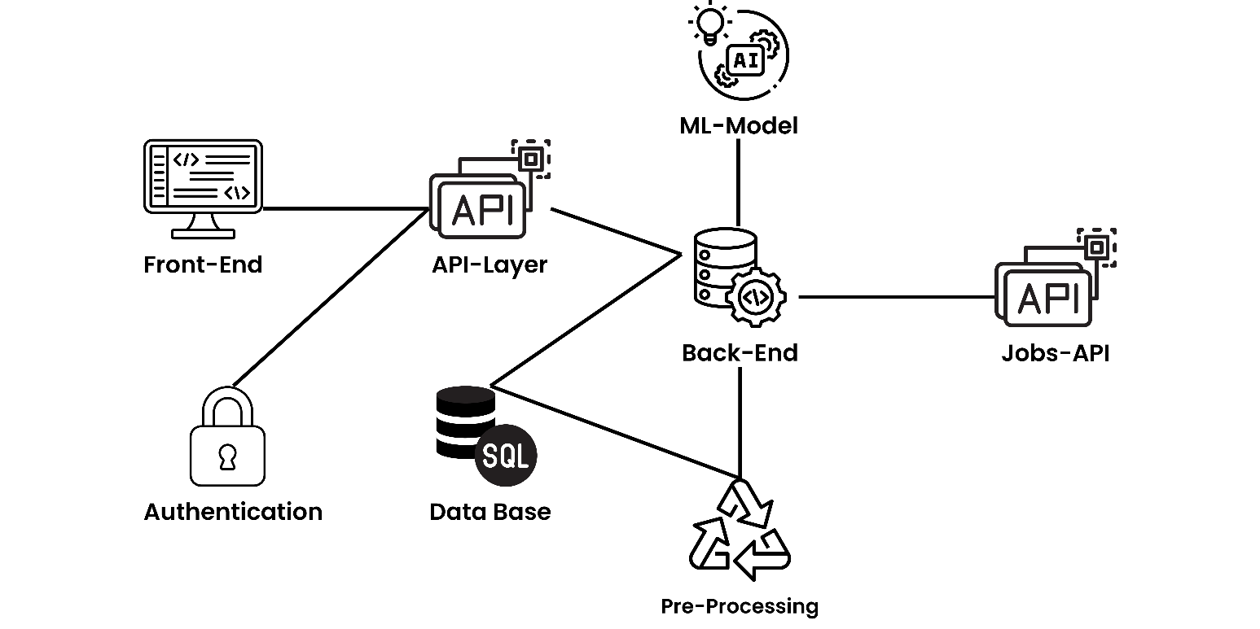

**Project Planning**

**5.1 Gantt Chart**

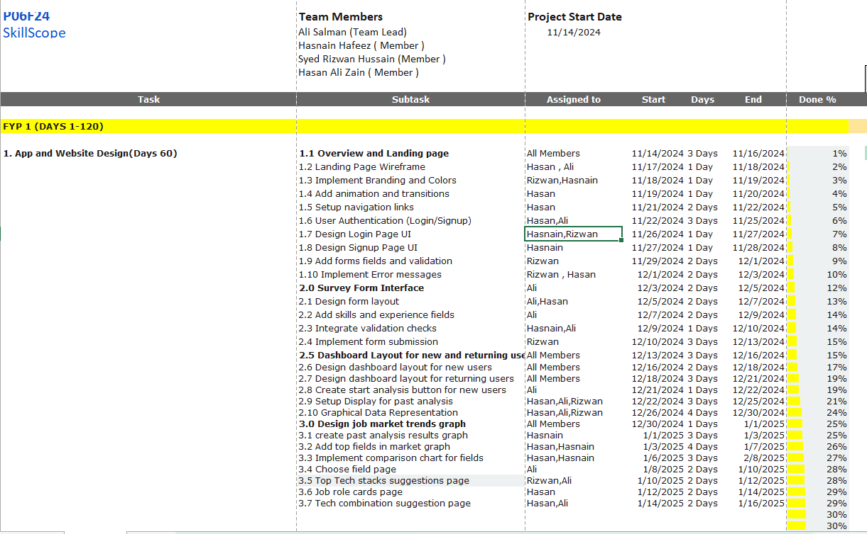

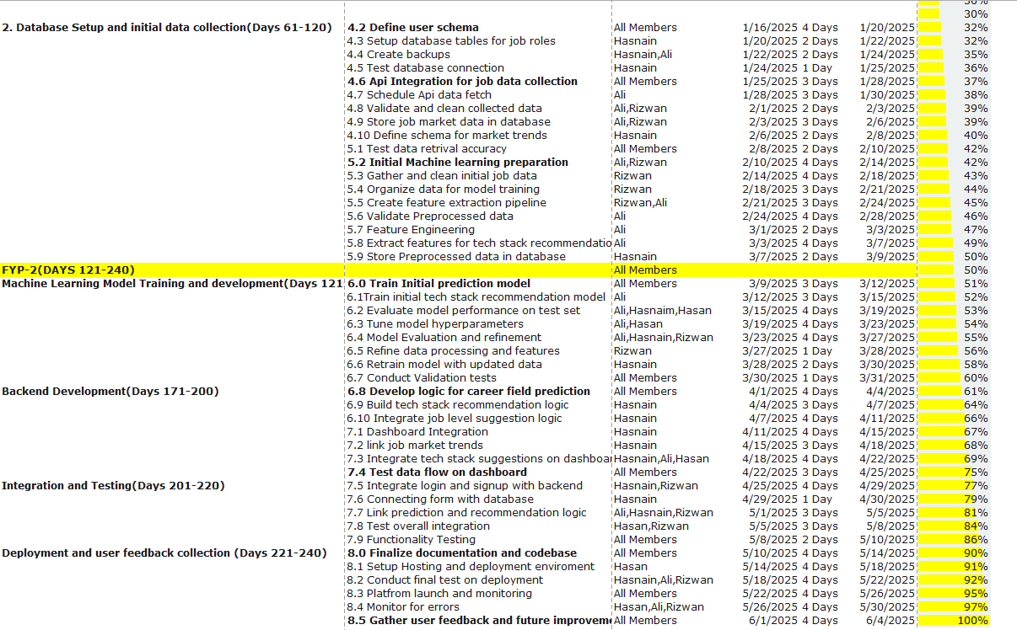

**6 Project Requirements**

**6.1 Software tools requirements:**

The prerequisite software & libraries for the sign language project are:

1. Python (3.12)
2. IDE (Jupyter)
3. NumPy (version 1.16.5)
4. Pandas
5. Matplotlib.pyplot
6. Seaborn
7. SciPy Toolkit Learn
8. NLTK or SpaCy
9. Keras (version 2.3.1)
10. Tensor flow
11. Rapid Api
12. React
13. Node.js
14. SQL/MongoDB
15. Vs code
16. Figma
17. Postman
18. Git
    1. **Hardware requirements:**
19. **Processor:**

A modern multi-core processor (Intel i5/i7 or AMD Ryzen 5/7) to handle programming, data analysis, and web development tasks smoothly.

1. **RAM**:

At least 8 GB of RAM (16 GB would be ideal) to manage multiple applications (IDE, browser, database, etc.) during development.

1. **Storage:**

SSD with at least 256 GB of storage. SSDs provide faster boot and load times, which is important when you're working with large data sets or web development environments.

1. **Graphics**:

Integrated graphics (like Intel UHD or AMD Vega) will be sufficient for development tasks. However, if you plan to work with complex data visualizations or machine learning models, a dedicated GPU (like Nvidia GTX) can speed up processing.

1. **Operating System:**

Windows 10/11, macOS, or Linux based on your personal preference and the stack you're using (e.g., Linux is often preferred for server-side development).

1. **Screen Resolution:**

A full HD display (1920x1080) for coding and web design, especially if you're working with complex UI/UX design tools.

**7 Budget/Costing**

**7.1 Estimated Budgeted Cost of the Project**

* + Total Hours – 640 hrs.
  + Per Hour Rate - 3000 Rs
  + Total Hours Rate - 1,920,000 PKR
  + Hardware Cost – 15,000 Rs
  + Other resources – 25,000 Rs
  + Api Cost – 30,000 Rs
  + **Total cost Rs. - 2,010,000 Rs**

**8 Project Deliverables:**

**8.1 Phase I – UI Prototype (FYP1)**

* Planning and requirements gathering
* Abstract Summary
* Project Proposal
* UI Design and Prototyping
* Front End development

**8.2 Phase II – Back End Integration and Beta Prototype (FYP2)**

* Backend Architecture design
* Backend Development
* Data model training and testing
* Full integration and testing

**8.3 Phase IV - Final Product**

* Fully operational product

**9 Proposed GUI (Prototype)**

Screenshot or User Interface

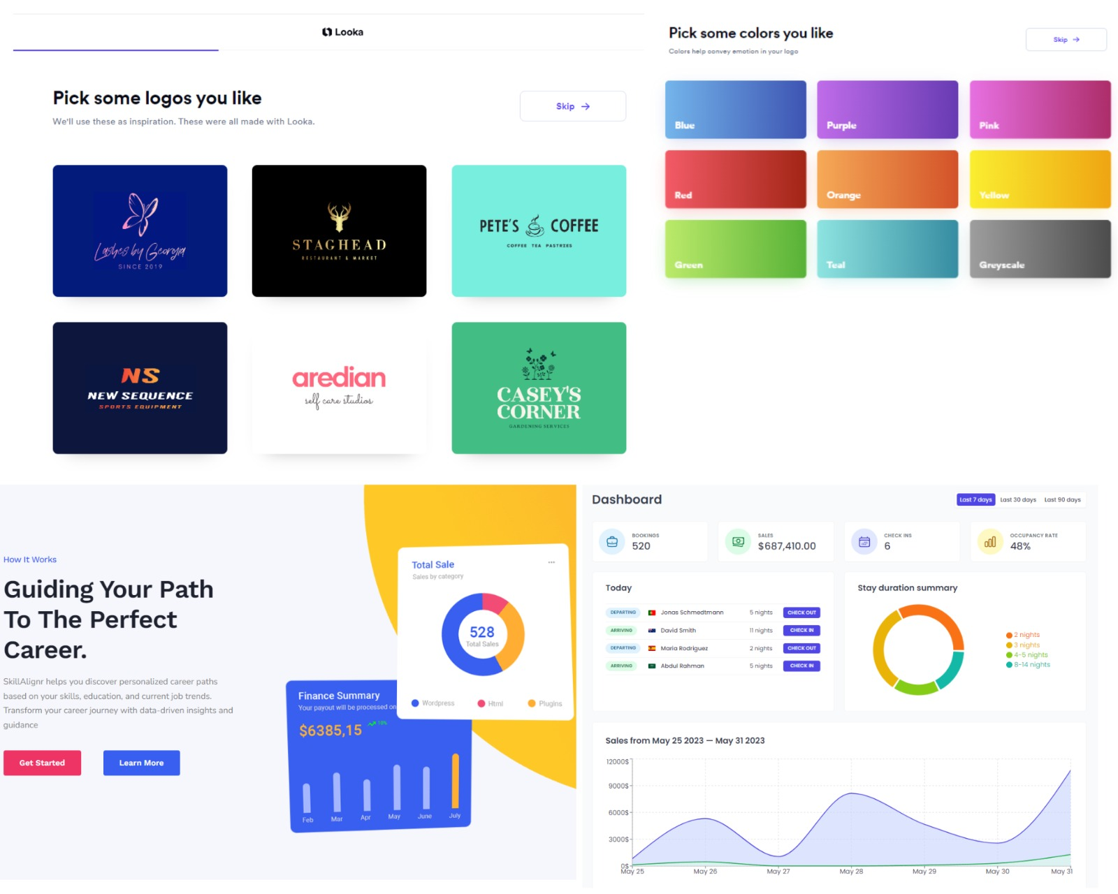

FYP Project Meeting # 1

Minutes of Meeting

Meeting Date: 31/10/2024

Meeting Location: Supervisor Room

Meeting Time: 12:30 – 1:30

**1- List of Participants**

|  |  |
| --- | --- |
| **Name** | **Project Role** |
| Ali Salman | Group Leader |
| Syed Rizwan Hussain | Group Member |
| Hasnain Hafeez | Group Member |
| Hassan Ali Zain | Group Member |

**2- Meeting Agenda**

* Project Idea Discussion

**3- Agenda Points discussed in meeting**

The meeting primarily focused on:

1-We discussed the various project concepts and how well they align with the talents and interests of the team.

2- We considered each concept's feasibility and alignment with the objectives of the Insight project.

**4- Action List**

* making of abstract summary

**5- Next Meeting for this project**

10-11-2024 at 11:00 pm same place

Supervisor/Co-Supervisor Signature _________________

FYP Project Meeting # 2

Minutes of Meeting

Meeting Date: 10/11/2023

Meeting Location: Supervisor Room

Meeting Time: 11:00 – 1:00

**1- List of Participants**

|  |  |
| --- | --- |
| **Name** | **Project Role** |
| Ali Salman | Group Leader |
| Syed Rizwan Hussain | Group Member |
| Hasnain Hafeez | Group Member |
| Hassan Ali Zain | Group Member |

**2- Meeting Agenda**

* Abstract Review

**3- Agenda Points discussed in meeting**

The meeting mainly focused on reviewing the project abstract. We discussed the following points:

Clarifying project objectives and scope.

Identifying areas for improvement to enhance clarity.

Ensuring the abstract aligns with the overall project vision.

**4- Action List**

* making of project proposals.

**5- Next Meeting for this project**

14-11-2024 at 2:00 pm same place

Supervisor/Co-Supervisor Signature _________________

FYP Project Meeting # 3

Minutes of Meeting

Meeting Date: 14/11/2023

Meeting Location: Supervisor Room

Meeting Time: 2:00 – 3:00

**1- List of Participants**

|  |  |
| --- | --- |
| **Name** | **Project Role** |
| Ali Salman | Group Leader |
| Syed Rizwan Hussain | Group Member |
| Hasnain Hafeez | Group Member |
| Hassan Ali Zain | Group Member |

**2- Meeting Agenda**

* Proposal review
* presentation discussion

**3- Agenda Points discussed in meeting**

We discussed the following in this meeting:

* Reviews of Proposal
* Reviews of PowerPoint Presentation
* Reviews of the abstract

**4- Action List**

* leader submitted the documents

**5- Next Meeting for this project**

25-11-2024 at 1:00 pm same place

Supervisor/Co-Supervisor Signature _________________

1. **References**
2. Brynjolfsson, E., Hitt, L. M., & Kim, H. H. (2011). Strength in Numbers: How Does Data-Driven Decision-Making Affect Firm Performance? Social Science Research Network. Available at: SSRN.
3. U.S. Bureau of Labor Statistics. (2020). Occupational Outlook Handbook: Computer and Information Technology Occupations. Available at: BLS.